SWE20004 Technical Software Development Semester 1 2020

Assignment 2 report

Name: Dipesh Goyal Student ID:102558284

Lab class: Friday,12:30 Tutor: Srikanth Thudmu

Due Date: Monday 4th May 2020

Date Submitted: 28/04/2020

Assignment Title: Credit Card Validator

Program description
This program utilizes the Luhn algorithm to detect invalid credit card numbers. This is done by comparing the checksum digit and the last digit of the credit card entered. The program takes input from user until -1 is entered. It then processes the input into the two functions to find the sumtotal and checksum. Once the checksum is calculated, it is then compared with the last digit of the credit card. If they match, the card is valid and if they do not its invalid.

Inputs and Outputs
The inputs and outputs for this program are described in Table 1.

Table 1. Data dictionary:
Data to be stored | Sample data | Type of data | C++ type | Input method | In /  Out |  | Variable name
Credit card number | 1 2 3 4 5 | Integer | int | cin | in |  | temp
Credit card numbers | 79927398713 | Integers | int array | For loop and array | out |  | array[]
Sum 1 numbers | 9 8 7 4 | Integer | int | Return from a function total1 | out |  | sum1
Sum 2 numbers | 7 9 7 9 | Integer | int | Return from a function total2 | out |  | sum2
Total of sum 1 and 2 numbers | 32 | Integer | int | (Sum1 + Sum2) * 9 | in |  | sumTotal
Checksum | 7 | Integer | int | sumTotal % 10 |  | out | checksum
Size of credit card number | 20 | Integer | Int | Increment from for loop | in |  | count

3. Algorithm
Program steps:
  - Prompt for input
  - Enter input
  - -1 to stop entering input
  - Only store input until -1
  - Display the input
  - Process the input entered in functions total1and total2
  - Store the return values from functions in Sum1 and Sum2
  - Display Sum1 and Sum1 numbers
  - Display Sum2 and Sum2 numbers
  - Calculate both sums total and multiply by 9
  - Get checksum sum by modulus 10 of sum total.
  - Display checksum and last digit of entered input.
  - Check if checksum and last digit of entered input match
  - If they match credit card is valid and if not, it is then invalid.
  - Display if credit card is valid or invalid

Coding logic:

Sum1 Function Logic:
START
int function total1(int array[],int arraySize)
integer total1, i, x, sum ,count initialized to 0
int array temp to size 10
print “Numbers for sum1 are”
For loop (i = arraysize – 2; i greater or equal to 0; i=i-2)
temp[count+1] = array[i];
increment count
x = array[i] multiply by 2
if (x is greater than 9)
x = x modulus 10
sum = 1 + x
total1 = total1 + sum
end if
else
total1+= array[i] multiply by 2
end for
for loop(i = count; i greater than 0; i decrement)
print temp[i]
end for
print “\n”
return tota1
end function
END

Sum2 Function Logic:
START
int function total2(int array[],int arraySize)
integer total2, i, count initialized to 0
int temp[10]
print “Numbers for sum2 are”
For loop (i = arraysize – 3; i greater or equal to 0; i=i-2)
temp[count+1] = array[i]
increment count
total2 = total2 + array[i]
end for
for(i= count; i greater than 0; i decrement)
print temp[i]
end for
return total2
end function
END

Checksum Logic:
START
int sumTotal initialized to 0
sumTotal = sum1+ sum2
sumTotal = sumTotal % 10
print “Checksum is “ checksum
print “Last digit of credit card is” array[count-1]
if (array[count-1] ==checksum)
print “Checksum digit and the last digit are the same. Valid Credit Card”
endif
else
print “Checksum digit and the last digit are not the same. Invalid Credit Card”
exit
END

Source code:
- #include <iostream>

- using namespace std;

- //Function Protypes
- int total1(int array[],int arraySize); // to get sum1
- int total2(int array[],int arraySize); // to get sum2

- int main()
- {
- int array[20];
- int i;
- int temp = 0;
- int count= 0;
- int sumTotal = 0;
- int checksum= 0;

- printf("Enter The Credit Card Number Below: \n");
- for (i = 0; i < 20; i++)
- {
- cin >> temp; // storing credit card numbers
- if (temp != -1) // stores till -1.
- {
- array[i] = temp; // storing in array.
- count++;
- }
- else
- break;
- }
- cout << "The Credit Card number is: ";
- int c;
- for (c = 0; c < count; c++)
- {
- cout <<array[c]; // print credit card number that is entered
- }
- cout << "\n";

- // SUM 1
- int sum1 = total1(array,count); // function is also printing sum numbers
- cout << "Sum 1 is " << sum1 << "\n";

- // SUM 2
- int sum2 = total2(array,count); // function is also printing sum numbers
- cout << "Sum 2 is " << sum2 << "\n";

- // CheckSum
- sumTotal = sum1 + sum2;
- sumTotal = sumTotal * 9;
- checksum = sumTotal % 10;
- cout << "Check sum is " << checksum << "\n";
- cout << "The last digit of the credit card is " << array[count - 1] << "\n";
- if (array[count - 1] == checksum)
- {
- cout << "Check sum digit "<< checksum << " and the last digit " << array[count - 1] << " are the same: Valid credit card number. \n";
- }
- else
- {
- cout << "Check sum digit "<< checksum << "and the lastdigit " << array[count - 1] << " are not the same: Invalid credit card number. \n";
- }
- return 0;
- }

- int total1(int array[],int arraySize) // Function to get sum1 numbers and sum1.
- {
- int total1=0;
- int i = 0;
- int x= 0;
- int sum= 0;
- int temp[10];
- int count = 0;
- cout<< "Numbers for sum1 are ";
- for (i = arraySize - 2; i >= 0; i = i - 2)
- {
- temp[count + 1] = array[i];
- count++;
- x = array[i] * 2;
- if (x > 9)
- {
- x = x % 10;
- sum = 1 + x;
- total1 = total1 + sum;
- }
- else
- {
- total1 += array[i] * 2;
- }
- }
- for (i = count; i > 0; i--)
- {
- cout << temp[i] << " ";// printing sum1 numbers
- }
- cout << "\n";
- return total1;
- }

- int total2(int array[],int arraySize) // Function to get sum2 numbers and sum2.
- {
- int total2= 0;
- int i = 0;
- int temp[10];
- int count = 0;
- cout<< "Numbers for sum2 are ";
- for(i = arraySize - 3; i >= 0; i = i - 2)
- {
- temp[count + 1] = array[i];
- count++;
- total2 = total2 + array[i];
- }
- for (i = count; i > 0; i--) // printing sum2 numbers
- {
- cout << temp[i] << " ";
- }
- cout << "\n";
- return total2;
- }

Screenshots showing working program (Show all possible outcome):
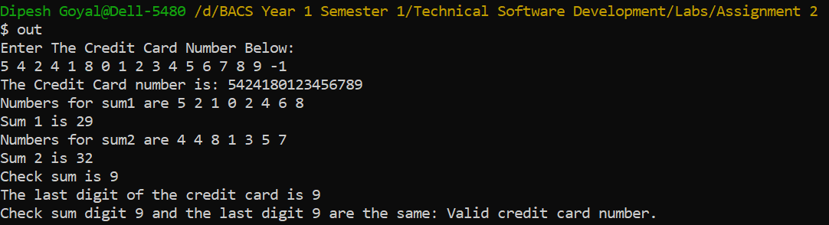
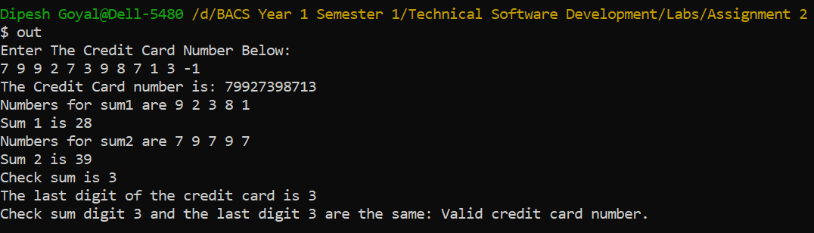
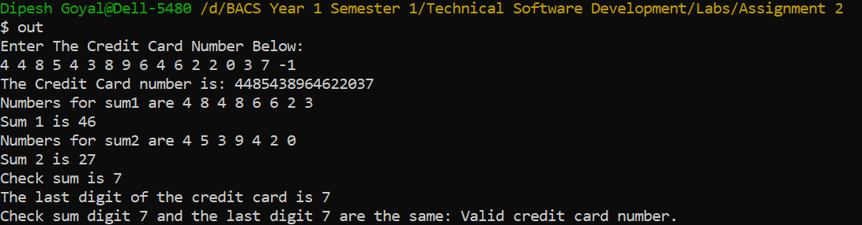
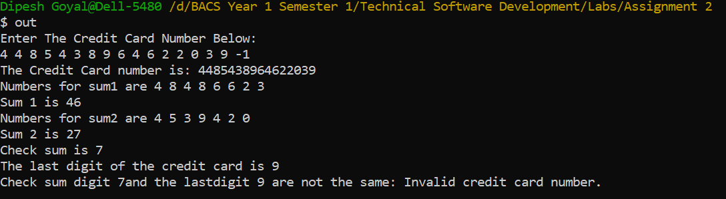

Task 5.3

Program description
This program is a “guess the number” game. The program choses a random number between 1-1000 and asks the user to guess the number. If the users guess is lower than the number chosen by the program it then prints Too low. Try again. If the guess is higher than the number than Too high. try again. This is repeated until user guesses the number. Comments are displayed when the user guesses the right number based on the attempts it took.

Source Code
- #include <iostream>
- #include <cstdlib>
- #include <ctime>
- using namespace std;

- //Function Prototypes
- int random(int num);
- void comment(int attempts);

- int main()
- {
- int num = random(num);
- int guess, attempts = 0;
- char answer = 'y';
- // Prompts User
- do // loop to keep running until users chose not to play.
- {
- cout << "I have a number between 1 and 1000.\n";
- cout << "Can you guess my number?\n";
- cout << "Enter a guess between 1 and 1000 : ";
- cin >> guess;
- attempts++;
- // Conditions to display message if guess is bigger or less than the number
- if (guess > num)
- {
- cout << "Too high. Try again\n";
- }
- else if (guess < num)
- {
- cout << "Too low. Try again\n";
- }
- else
- {
- // When user wins
- cout << "\nExcellent! You guessed the number!\n";
- comment(attempts);
- cout << "Would you like to play again?\n";
- cout << "Please type y or n?\n"; // Prompt if they want to play again or not
- cin >> answer;
- if(answer == 'y')
- {
- num = random(num);
- guess = 0;
- attempts = 0;
- }
- }
- } while (answer == 'y');
- return 0;
- }

- //Function 1
- int random(int num) // Function to generate random number
- {
- srand(time(NULL)); //seed random number generator
- num = rand() % 1000 + 1; // random number between 1 and 100
- return num;
- }

- //Function 2
- void comment(int attempts) // function to display comment based on number of attempts
- {
- // Condition to check number of attempts and displasy message accordingly
- if(attempts <= 10){
- cout << "Either you know the secret or you got lucky!\n";
- }
- else if(attempts == 10){
- cout << "Ahah! You know the secret!\n";
- }
- else if(attempts >= 10){
- cout << "You should be able to do better!\n";
- }
- }

Screenshots showing working program
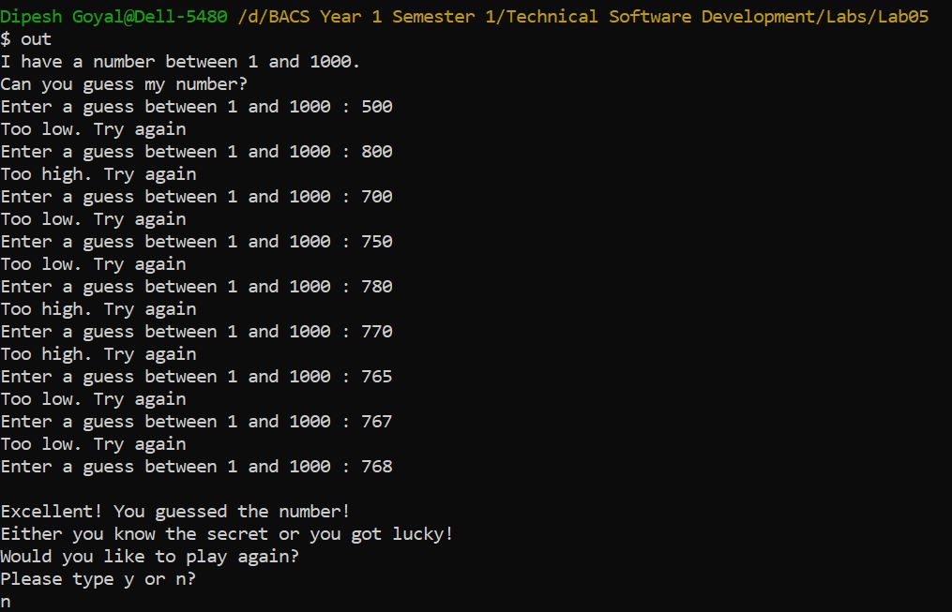

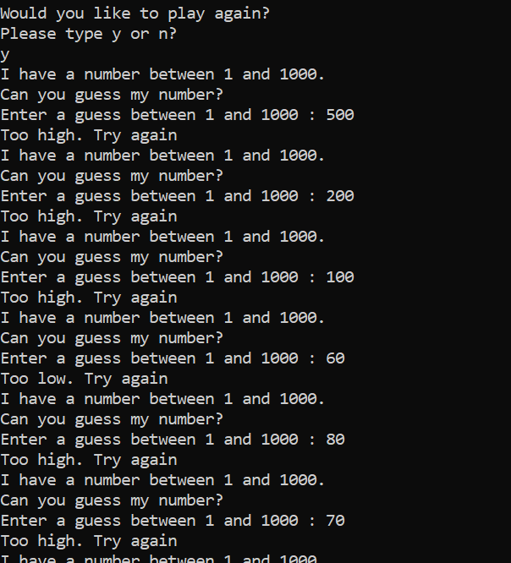

Task 5.4

Program description
This program is a “roll the dice” game. The program randomly rolls 2 dice. If the sum of those 2 dice is 7 or 11. The player wins. If the sum is 2, 3 or 12 on the first roll. The player loses. If the player gets any other number than between 1-12 on the first roll. They then score a point and have to keep rerolling until they make the same point again but if they get a 7 before making a point again, they lose. The player can set the wager if they have sufficient funds in their bank balance. Winning and losing will increase or lower their bank balance. Comments are also displayed between the games to keep it interesting.

Source Code
- #include <iostream>
- #include <ctime>

- using namespace std;

- //Function Prototypes
- int Random();
- int bankBalanceWin(int balance, int wager);
- int bankBalanceLose(int balance, int wager);

- int main()
- {
- //variable declaration
- int dice1 = Random();
- int dice2 = Random();
- int bankBalance = 100; // bank balance
- int wager = 0;
- int sum2 = 0;
- int sum = 0;
- char answer = 'y';
- do // loop to keep running until users chose not to play.
- {
- cout << "You have $ " << bankBalance << " in the bank.\n";
- do
- { // loop to keep running if wager is higher than bank balance
- cout << "Place your wager: ";
- cin >> wager;
- if(wager > bankBalance)
- {
- cout << "The wager amount cannot exceed your bank balance. Please try again!\n";
- }
- }while(wager > bankBalance);

- cout << "\nRolling the dice....\n";
- cin.ignore();
- sum = dice1 + dice2;
- //Displays the dice1 and 2 with the sum
- cout << "Player rolled " << dice1 << " + " << dice2 << " = " << sum << "\n";

- if(sum == 7 || sum == 11)
- {
- // when plater wins
- cout << "Player Wins!!\n";
- cout << "You're up big. Now's the time to cash in your chips!\n";
- cout << "Your new bank balance is: " << bankBalanceWin(bankBalance,wager) << "\n";
- cout << "Please type y or n?\n"; // Prompt if they want to play again or not
- cin >> answer;
- if(answer == 'y')
- {
- bankBalance = bankBalanceWin(bankBalance,wager);
- dice1 = Random();
- dice2 = Random();
- wager = 0;
- sum=0;
- sum2 = 0;
- }
- }
- else if(sum == 2 || sum == 3 || sum == 12)
- {
- cout << "Player Lost.\n";
- cout << "Sorry. You busted!\n";
- cout << "Your new bank balance is: " << bankBalanceLose(bankBalance,wager) << "\n";
- cout << "Please type y or n?\n"; // Prompt if they want to play again or not
- cin >> answer;
- if(answer == 'y')
- {
- bankBalance = bankBalanceLose(bankBalance,wager);
- dice1 = Random();
- dice2 = Random();
- wager = 0;
- sum = 0;
- sum2 = 0;
- }
- }
- else
- {
- // when a point is made
- cout << "Player made a point!\n";
- cout << "Point is: " << sum << "\n";
- cout << "Aw cmon, take a chance!\n";
- do
- {
- // reset values of dice 1 and dice 2.
- dice1 = Random();
- dice2 = Random();
- cout << "Press any key to reroll.\n";
- cin.ignore();
- // new sum if player makes a point
- int sum2 = dice1 + dice2;
- cout << "Player rolled " << dice1 << " + " << dice2 << " = " << sum2 << "\n";
- if(sum==sum2)
- {
- cout << "Player Wins!!\n";
- cout << "Nice Win. Better cash those chips now!!\n";
- cout << "Your new bank balance is: " << bankBalanceWin(bankBalance,wager) << "\n"; // function to display
- cout << "Please type y or n?\n"; // Prompt if they want to play again or not
- cin >> answer;
- if(answer == 'y')
- {
- bankBalance = bankBalanceWin(bankBalance,wager);
- dice1 = Random();
- dice2 = Random();
- wager = 0;
- sum2 = 0;
- sum = 0 ;
- }
- break;
- }
- else if(sum2==7)
- {
- //Player loses if summ is equal to 7
- cout << "Player Lost.\n";
- cout << "Oh, you're going for broke, huh?\n";
- cout << "Your new bank balance is: " << bankBalanceLose(bankBalance,wager) << "\n"; // function to display
- cout << "Would you like to play again?\n";
- cout << "Please type y or n?\n"; // Prompt if they want to play again or not
- cin >> answer;
- if(answer == 'y')
- {
- bankBalance = bankBalanceLose(bankBalance,wager);
- dice1 = Random();
- dice2 = Random();
- wager = 0;
- sum = 0 ;
- sum2 = 0;
- }
- break;
- }
- }while(sum !=sum2 || sum2 != 7); // loop to keep running until player loses or wins
- }
- } while (answer == 'y');
- return 0;

- }
- //Function to generate random number
- int Random()
- {
- int number;
- static int flag = 1; //static so only meets the condition once.
- if (flag == 1) // this ensures the function gives different random numbers everytime.
- {
- srand(time(0));
- flag = 0;
- }
- number = rand() % 6 + 1;
- return number;
- }

- // Function to add balance and wager when player wins.
- int bankBalanceWin(int balance, int wager)
- {
- return wager + balance;
- }
- // Function to minus the wager from balance when player loses.
- int bankBalanceLose(int balance, int wager)
- {
- return balance - wager;
- }

Screenshots showing working program
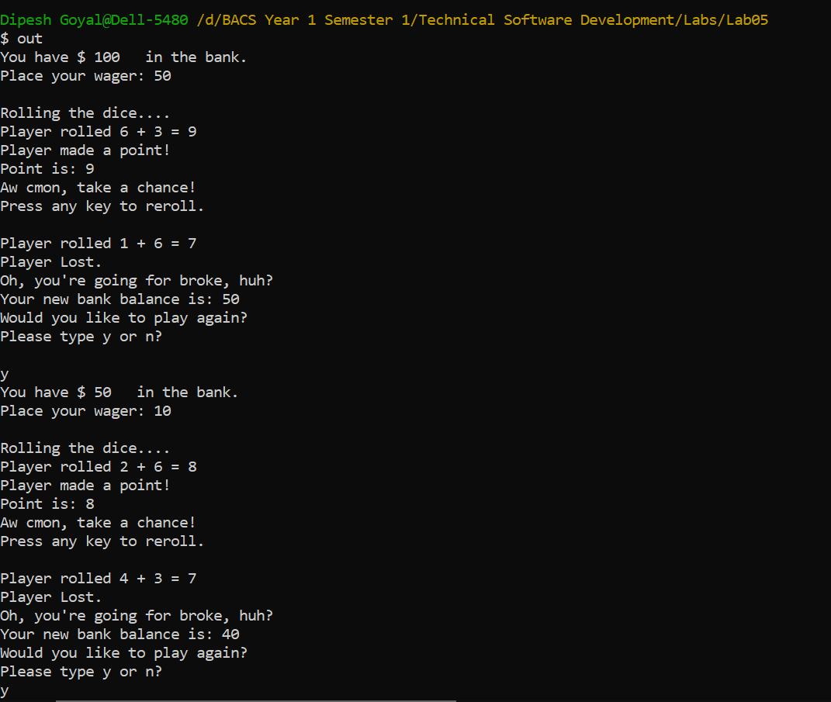
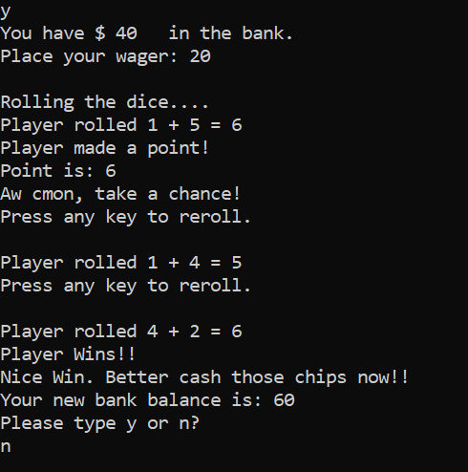
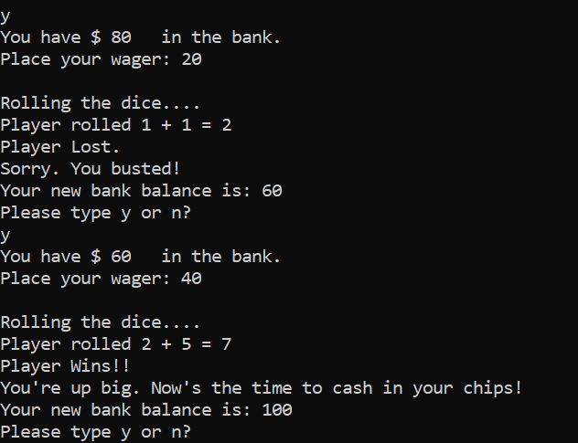

Task 6.3

Program description
This program takes 20 alphabets that are stored in a one-dimensional array. It indicates if the user enters a duplicate letter that already exists in the array. It also validates and warns the user if they enter a non- alphabet. Program only stores alphabets in the array. When 20 alphabets are entered, it then displays the original array that was entered and the alphabetically sorted array. The program displays a mode if a most occurring alphabet was detected. If the array had all duplicate letters it then indicates that all character in the array are same. Also, if the array had no mode, it then displays the message that All characters are entered only one time.

Source Code
- #include <iostream>
- #include <string>
- #include <cstdlib>

- using namespace std;

- //Function Protypes
- void readArray(char input[], int size);
- void alphabetSort(char input[], int size);
- void frequency(char input[], int size);

- int main() //MAIN Function
- {
- char input[20]; // Array of 20 characters
- readArray(input, 20);
- alphabetSort(input, 20);
- frequency(input, 20);
- }

- void readArray(char input[], int size) //Function to store characters in array and check for duplicate and letters
- {
- int i, c;
- char m;

- for (i = 0; i < size; i++)
- {
- cout << "Enter character \n";
- fflush(stdin);
- cin >> m;
- if (tolower(m) < 'a' || tolower(m) > 'z') // Check if alphabet or not
- {
- cout << m << " is not an alphabet\n";
- i--;
- }
- else
- input[i] = m;
- for (c = 0; c < i; c++)
- {

- if (input[c] == input[i]) // if matches it is a duplicate
- {
- cout << input[c] << " is a duplicate letter.\n";
- c = i;
- }
- }
- }
- cout << "\n";
- cout << "The original array is:\n"; // Prints the original array
- for (i = 0; i < size; i++)
- {
- cout << input[i];
- }

- }

- void alphabetSort(char input[], int size) // Function to sort the array in alphabatical order
- {
- int i = 0, m = 0;
- char L;
- for (i = 0; i < size; i++)
- {
- for (m = i + 1; m < size; m++)
- {
- if (tolower(input[i]) > tolower(input[m]))
- {
- L = input[i];
- input[i] = input[m];
- input[m] = L;
- }
- }
- }
- cout << "\nThe sorted array is:\n"; // Prints the sorted array
- for (i = 0; i < size; i++)
- {
- cout << input[i];
- }
- }

- void frequency(char input[], int size) // Frequent Letter function
- {
- char mode[20];
- int count=0, Max=0, a=0, fre[20], i, j;

- for(i=0; i<size; i++)
- {
- count =1;
- for(j=i+1; j<size; j++)
- {
- if(input[i] == input[j])
- count++;
- else
- break;
- }
- mode[a]= input[i];
- fre[a]= count;
- if(Max<count)
- Max = count;
- a++;
- i = j-1;
- }
- for(i=0; i<size; i++)
- {
- if(Max == 1){ // If the max is 1 means the all occurences only happened once.
- cout << "\nAll characters are entered only one time.\n";
- break;
- }else if(Max == size){ // if max is equal to size means all characters are different
- cout << "\nAll characters are the same.\n";
- break;
- }else if(Max == fre[i]){ // to print occurences more than 1
- cout << "\nThe mode is '" << mode[i] << "' and it is occuring " << fre[i] << " times.\n";
- break;
- }
- }
- }

Screenshots showing working program

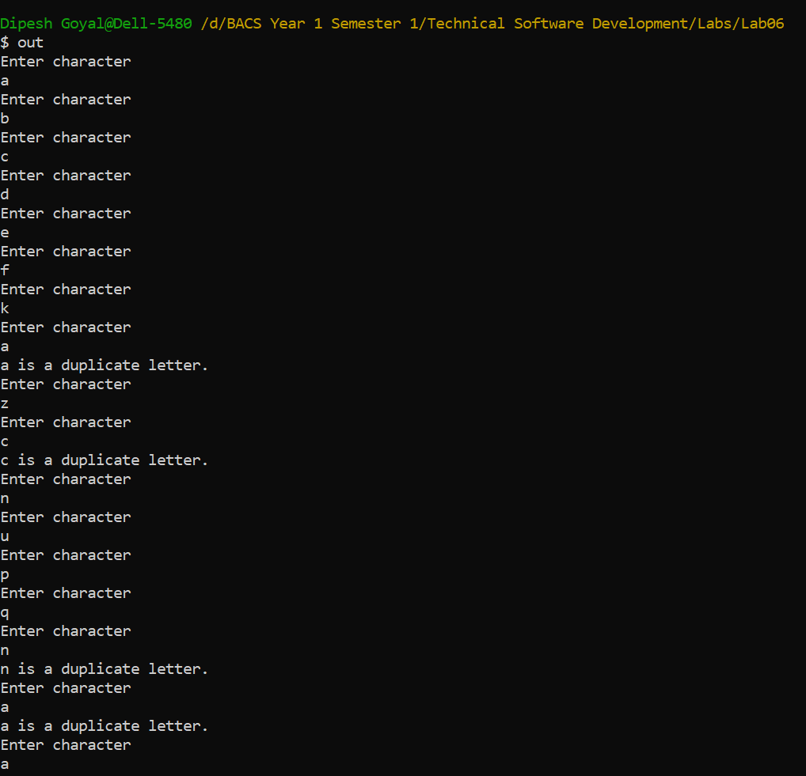
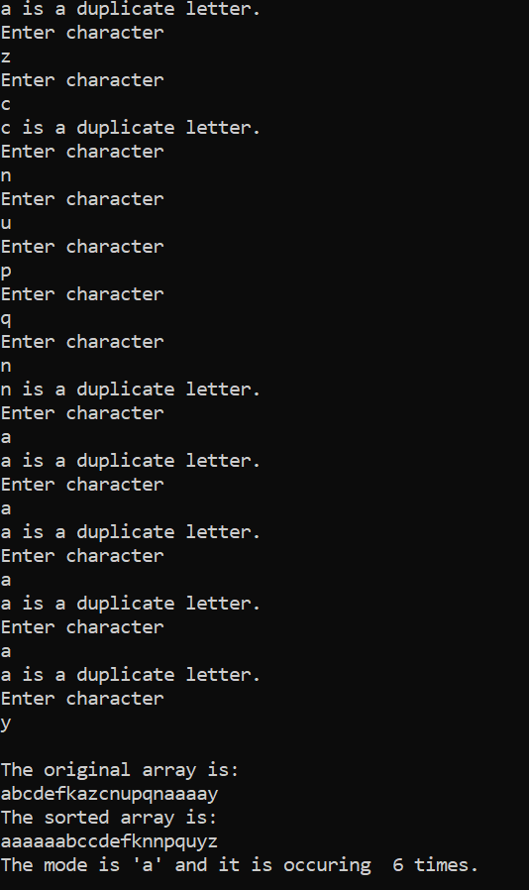
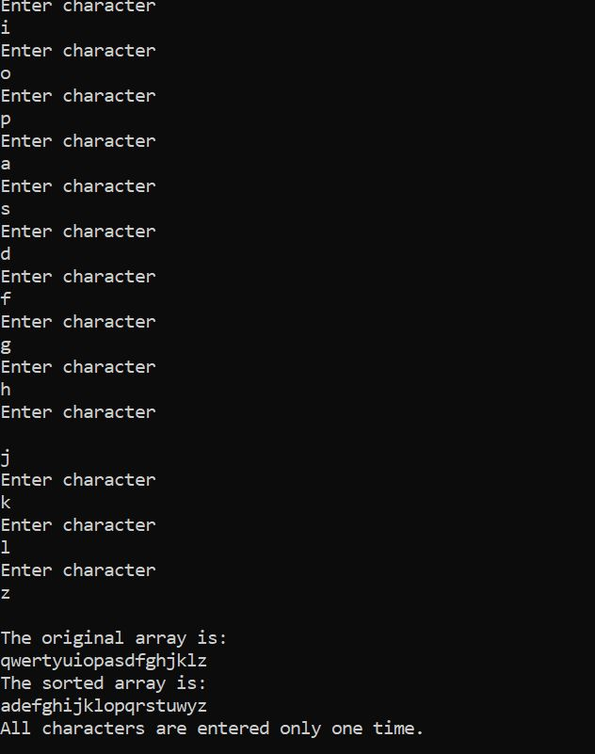

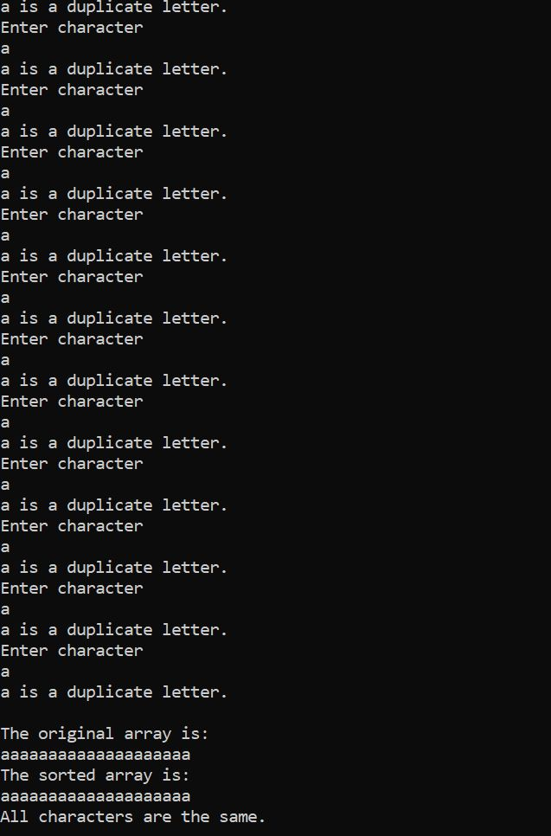

Task 6.4

Program description
This program simulates rolling of two dices. It then calculates the sum of the two dices. There are 36 possible combinations of the two dice. The program rolls the two dice 50,000 times. It then uses a 2D array to tally the numbers of each possible sum. It then prints the 2D array in a tabular format. If the total of the diagonal elements is greater than 8350 the player wins, otherwise the player loses.

Source Code
- #include <iostream>
- #include <iomanip>
- #include <ctime>

- using namespace std;

- int Random(); //Function Prototype

- int main()
- {
- int i;
- int j;
- int sum =0;
- int dice1;
- int dice2;
- int total = 0;
- const int columnSize = 6;
- const int rowSize = 6;
- int diagonal[6];
- int faces[columnSize][rowSize]; // two dimensional array
- for (int row = 0; row < 6; row++)
- {
- for (int column = 0; column < 6; column++)
- faces[row][column] = 0;
- }
- for (int i = 0; i < 50000; i++) // runs 50000 times
- {
- dice1 = Random();
- dice2 = Random();

- faces[dice1][dice2]++;
- faces[6][6] = faces[dice1][dice2];
- }
- cout<< "\n-----\t-----\t-----\t-----\t-----\t-----";
- for(int row = 0; row < 6; row++)
- {

- cout<<endl;
- cout<< ":";
- for(int column = 0; column < 6; column++)
- {
- cout<< faces[column][row] << " :" << "\t";

- }
- cout<< "\n-----\t-----\t-----\t-----\t-----\t-----";
- }
- cout << "\n";
- cout << "\nThe sum of the diagonal element is \n";
- for (i=0;i < rowSize;++i)
- {
- for (j=0;j < columnSize;++j)
- {
- if (i==j)
- cout << "\n" << faces[i][j] ;
- }
- }
- cout << " +\n";
- cout << "-------\n";
- for(i=0;i<6;i++)
- {
- for(j=0;j<6;j++)
- {
- if(i==j)
- sum=sum+faces[i][j]; // total of diagonals
- }
- }
- cout << sum << "\n";
- if(sum > 8350){
- cout << sum << " is greater than 8350, the player wins the game !!!\n";
- }else if( sum < 8350){
- cout << sum << " is less than 8350, the player lost the game !!!\n";
- }

- return 0;

- }

- int Random()
- {
- int number;
- static int flag = 1; //static so only meets the condition once.

- if (flag == 1)
- {
- srand(time(0));
- flag = 0;
- }
- number = rand() % 6;
- return number;
- }

Screenshots showing working program
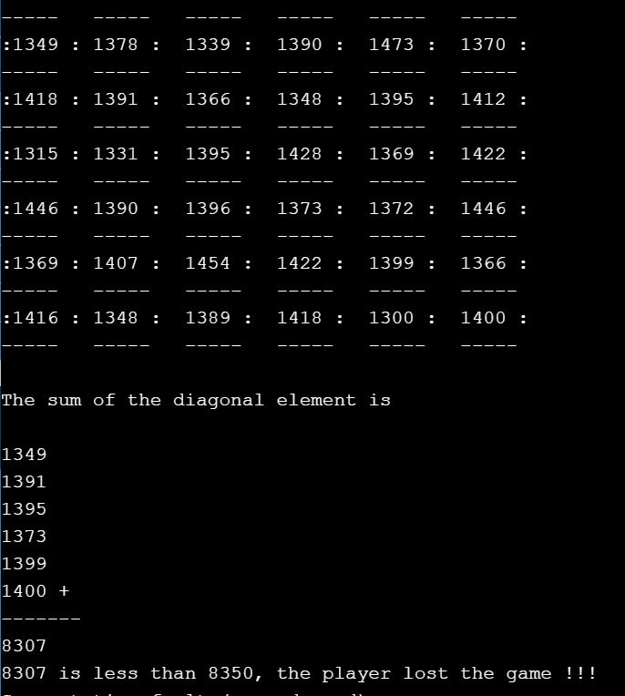
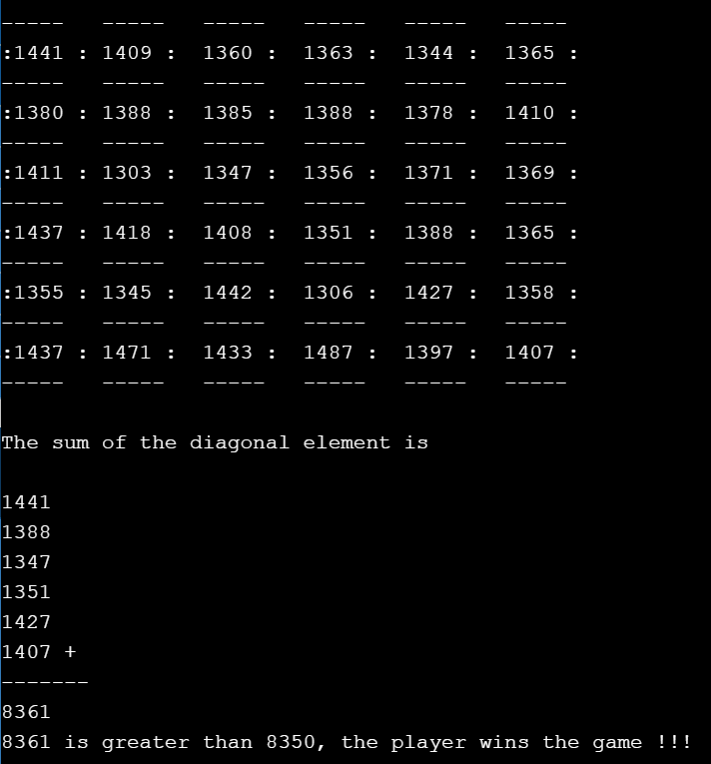

Task 7.1

Program description
This program reads a file “price.dat”. The first line contains an integer that specifies the number of records that follow. Once the file is successfully opened. The total price is calculated in a loop and the min, max is found by using if statements. The file is then closed. The summary report with max, min, average and no. records is then printed in terminal and also into an output file called “output.dat”.

Source Code
- #include <iostream>
- #include <fstream>
- #include <iomanip>

- using namespace std;

- int main()
- {
- string filename = "price.dat";
- int descrip;
- double price = 0;
- int count = 0;
- double total = 0;
- float max = 0;
- double min = 10000000; // for condition to satisfy
- int i;

- ifstream inFile;

- inFile.open(filename.c_str());

- if (inFile.fail()) // if file doesnt open successfully
- {
- cout << "The File was not opened successfully\n";
- cout << "Please check that the file currently exists\n";
- return 0;
- }
- inFile >> count; // storing number of records in count

- for (i = 0; i < count; i++) // for loop to get the total, min and max
- {
- inFile >> descrip >> price;
- total = total + price; // total for average
- if (max < price) // condition for max
- max = price;
- if (min > price) // condition for min
- min = price;
- }
- inFile.close(); // file close

- // display output in terminal
- cout << "Number of price readings: " << count << "\n";
- cout << "Maximum price: " << setprecision(2) << fixed << max << "\n";
- cout << "Minimum price: " << min << "\n";
- cout << "Average price: " << total / count << "\n";

- ofstream outFile;
- //write output to file.
- outFile.open("output.dat");
- outFile << "Number of price readings: " << count << "\n";
- outFile << "Maximum price: " << setprecision(2) << fixed << max << "\n";
- outFile << "Minimum price: " << min << "\n";
- outFile << "Average price: " << total / count << "\n";

- outFile.close(); // close output file.

- return 0;
- }

Screenshots showing working program
